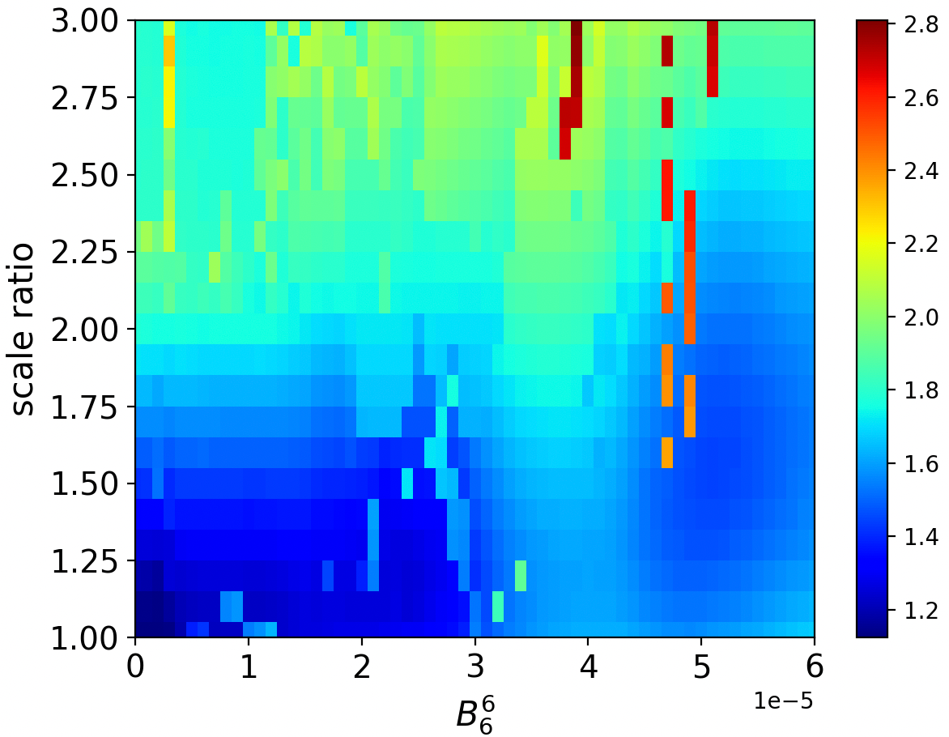

Global minimum: ratio=1.2, B66 = 3e-6, chisq = 22.543151574439825

Local minimum: ratio=1.4, B66 = 24e-6, chisq =23.497272783801126

Ratio = 1.8, B66 = 51e-6, chisq = 29.80248541479792